Energy Conversion Laboratory Report 1

Prepared by
Yunus Emre Turunç – 150721854
Abdullah Atak – 150721823
Antonio Jesus Mendez Millán – 199523051
Alvaro Merino Carrero – 199523050

Contents,
- First Question Solution
- First Question MATLAB Code
- Second Question Solution

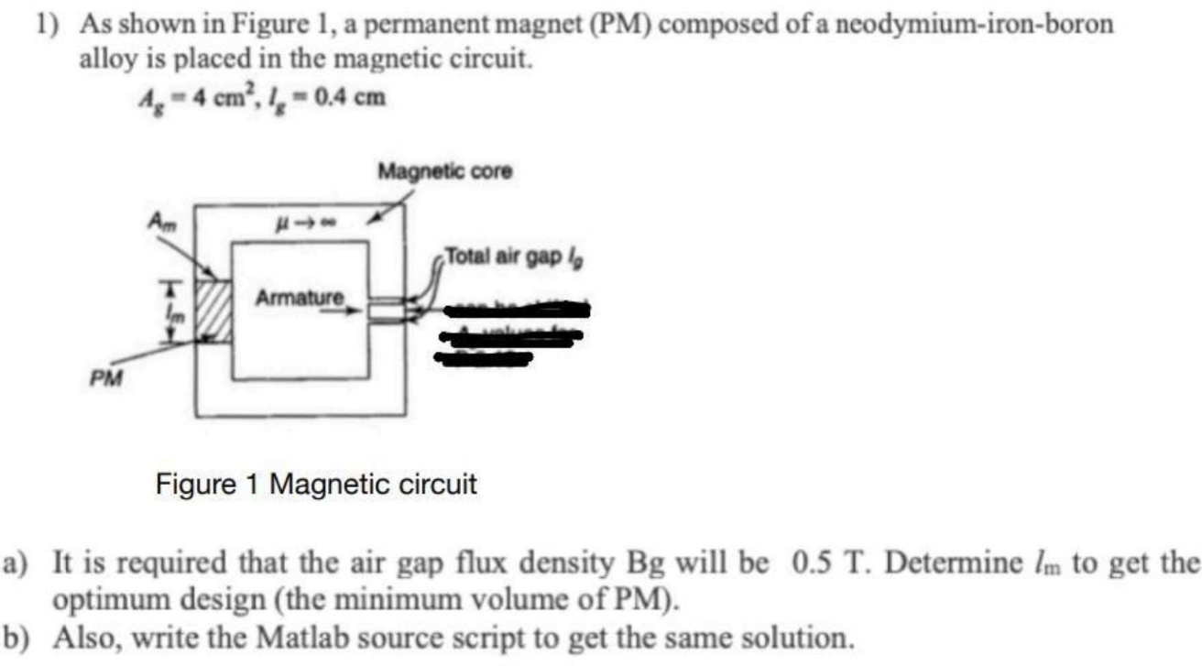

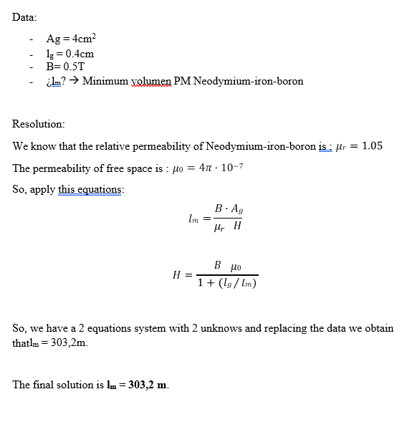

MATLAB Code of First Question

% M-file Labrotary Experiment 1
% Solution of Question 1

Ag = 0.0004; % Area of gap (m^2)
Lg = 0.004; % Lenght of the gap (m)
B = 0.5; % Flux density (T)

% We are looking for Lm (Minimum volumen PM Neodymium-iron-boron)

% Solution
% We know that the relative permeability of Neodymium-iron-boron is : 𝜇𝑟 = 1.05
% The permeability of free space is : 𝜇0 = 4𝜋 x 10^−7
% So apply this equation

M0 = 4*pi*1E-7;
Mr = 1.05;

%Lm = (B*Ag)/(Mr*H);
%H = (B*M0)/(1+(Lg/Lm));

syms Lm H

% İlk denklem
eq1 = Lm == (B * Ag) / (Mr * H);

% İkinci denklem
eq2 = H == (B * M0) / (1 + (Lg / Lm));

% Denklemleri çözün
solution = solve([eq1, eq2], [Lm, H]);

% Lm sonucunu görüntüle
Lm_result = solution.Lm;

% There are two results of Lm, one of them is positive so this is the
% answer : 303.1563

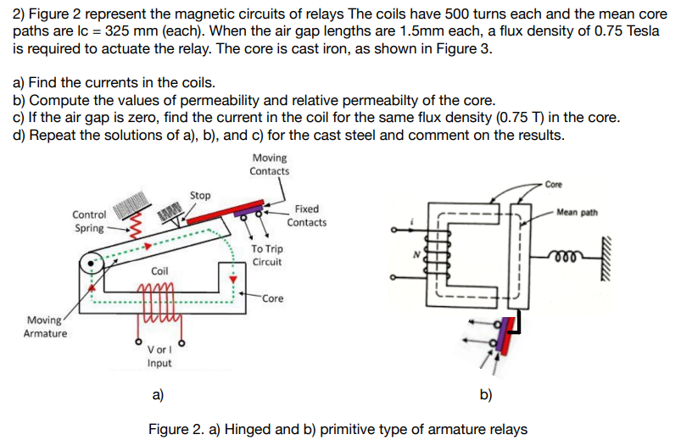

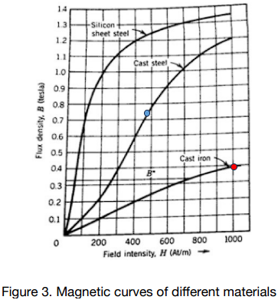
- Find the currents in the coils.

For the current calculation we can use the following equation.

$$F=NI=Hl_{c}$$

As you can see in Figure-3, Determining the H for the cast iron you can see the red point on the graph where the flux density reaches its limit is called Magnetic Saturation also known as Saturation of the Core. In our example above the saturation point of the iron curve begins at about 1000 ampere-turns per meter. So, we can use the value of H as 1000 and we know the mean core path as 325mm.
For the MMF (Magnetomotive Force) in the Core,
$$F=Hl_{c}$$
$$F_{c}=1000*0.325=325 (At)$$

MMF (Magnetomotive Force) for the Air Gap,
$$F_{g}=H{2l}_{g}=\frac{β{2l}_{g}}{μ_{0}}$$
Air gap lengths are 1.5mm each. The permeability of free space is 4πx10⁻⁷. Magnetic Flux Density is 0.75T.
$$F_{g}=\frac{0.75*2*1.5*{10}^{-3}}{4*π*{10}^{-7}}=1790.5 (At)$$
Total MMF:
$$F=F_{c}+F_{g}=325+1790.5=2115.5 (At)$$
Therefore, the current in the coil is
$$i=\frac{F}{N}=\frac{2115.5}{500}=4.23 A$$
- Compute the values of permeability and relative permeability of the core.

We can use the following equations for calculating permeability and relative permeability.

For the core permeability

$$μ_{c}=\frac{β}{H}=\frac{0.75}{1000}=0.00075 (H/m)$$

For the relative permeability

$$μ_{r}=\frac{μ_{c}}{μ_{0}}=\frac{0.00075}{4*π*{10}^{-7}}=596.8$$

- If the air gap is zero, find the current in the coil for the same flux density (0.75 T) in the core.

We can use the same following equation for calculating current.

$$F=NI=Hl_{c}$$
$$F_{c}=1000*0.325=325 (At)$$

Therefore, the current in the coil is

$$i=\frac{F_{c}}{N}=\frac{325}{500}=0.65 A$$
- Repeat the solutions of a), b), and c) for the cast steel and comment on the results.

- Find the currents in the coils.
We can use the same steps as above for the current calculation.

$$F=NI=Hl_{c}$$

As you can see in Figure-3, We know the magnetic flux density is same 0.75 T. So, we can use the H for the cast steel as 475 (At/m).

For the MMF (Magnetomotive Force) in the Core,
$$F=Hl_{c}$$
$$F_{c}=475*0.325=154.4 (At)$$

MMF (Magnetomotive Force) for the Air Gap,
$$F_{g}=H{2l}_{g}=\frac{β{2l}_{g}}{μ_{0}}$$
Air gap lengths are 1.5mm each. The permeability of free space is 4πx10⁻⁷. Magnetic Flux Density is 0.75T.
$$F_{g}=\frac{0.75*2*1.5*{10}^{-3}}{4*π*{10}^{-7}}=1790.5 (At)$$
Total MMF:
$$F=F_{c}+F_{g}=154.4+1790.5=1944.9 (At)$$

Therefore, the current in the coil is
$$i=\frac{F}{N}=\frac{1944.9}{500}=3.9 A$$
- Compute the values of permeability and relative permeability of the core.

We can use the following equations for calculating permeability and relative permeability.

For the core permeability

$$μ_{c}=\frac{β}{H}=\frac{0.75}{475}=0.001579 \left(H/m\right)$$

For the relative permeability
$$μ_{r}=\frac{μ_{c}}{μ_{0}}=\frac{0.001579}{4*π*{10}^{-7}}=5540$$
- If the air gap is zero, find the current in the coil for the same flux density (0.75 T) in the core.

We can use the same following equation for calculating current.

$$F=NI=Hl_{c}$$
$$F_{c}=475*0.325=154.4 (At)$$

Therefore, the current in the coil is

$$i=\frac{F_{c}}{N}=\frac{154.4}{500}=0.31 A$$

